Basnett Street Nursery School & The Chatterbox Club

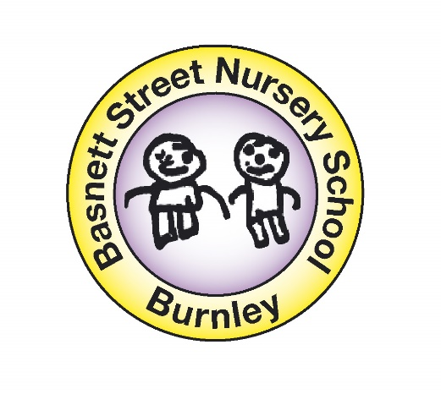

Low Level Concerns Policy

November 2023

1: Introduction
At Basnett Street Nursery School & The Chatterbox Club, we aim to create an open and transparent culture where all concerns about all adults involved with our school are dealt with promptly and appropriately. We aim to identify any concerning, problematic or inappropriate behaviour early; minimise the risk of abuse; and ensure that adults working in or on behalf of our school are clear about professional boundaries and act within these boundaries, and in accordance with our school ethos. This policy should be read alongside our Safeguarding and Child Protection and Staff Code of Conduct Policies.

2: Summary
It may be possible that a member of staff acts in a way that does not cause risk to children, but is however inappropriate. A member of staff who has a concern about another member of staff, volunteer, contractor or who, on reflection, recognises that their actions could have been viewed as a risk should inform the Head Teacher about their concern using a Low-Level Record of Concern Form. If the Head Teacher cannot be contacted, the Chair of Governors should be contacted instead.

3: Keeping Children Safe in Education September 2023
The following is taken from Keeping Children Safe in Education September 2023 and identifies what may be considered behaviour relating to low level concern:
427•: ‘What is a low level concern (LLC)?
The term ‘low-level’ concern does not mean that it is insignificant, it means that the behaviour towards a child does not meet the threshold set (on page four of this policy in the red box). A low-level concern is any concern – no matter how small, and even if no more than causing a sense of unease or a ‘nagging doubt’ - that an adult working in or on behalf of the school or college may have acted in a way that:
• is inconsistent with the staff code of conduct, including inappropriate conduct outside of work; and
• does not meet the allegations threshold or is otherwise not considered serious enough to consider a referral to the LADO.
Examples of such behaviour could include, but are not limited to:
• being over friendly with children;
• having favourites;
• taking photographs of children on their mobile phone;
• engaging with a child on a one-to-one basis in a secluded area or behind a closed door; or,
• humiliating children.
428. Such behaviour can exist on a wide spectrum, from the inadvertent or thoughtless, or behaviour that may look to be inappropriate, but might not be in specific circumstances, through to that which is ultimately intended to enable abuse.
429. Low-level concerns may arise in several ways and from a number of sources. For example: suspicion; complaint; or disclosure made by a child, parent or other adult within or outside of the organisation; or as a result of vetting checks undertaken.
430. It is crucial that all low-level concerns are shared responsibly with the right person and recorded and dealt with appropriately. Ensuring they are dealt with effectively should also protect those working in or on behalf of schools and colleges from becoming the subject of potential false low-level concerns or misunderstandings.

4: Clarity around Allegation vs Low-Level Concern vs Appropriate Conduct
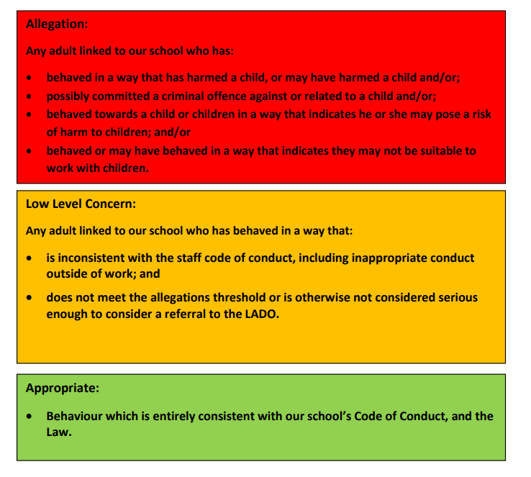
5: Reporting Low Level Concerns:
All Low Level Concerns must be reported to the Headteacher, recorded in writing using Low Level Concerns Reporting Form (see Part 8). If the concern is regarding the Headteacher, the Chair of Governors should be informed.

6: Storing and use of Low-Level Concerns and follow-up information
Low Level Concern forms and follow-up information will be stored securely within the schools safeguarding systems, with access only by the leadership team. This will be stored in accordance with the school’s GDPR and data protection policies. The staff member(s) reporting the concern must keep the information confidential and not share the concern with others apart from the Head Teacher or those aware in the senior leadership team. Low-Level Concerns will not be referred to in references unless they have been formalised into more significant concerns resulting in disciplinary or misconduct procedures. Whenever staff leave Basnett Street Nursery School & The Chatterbox Club, any record of low-level concerns which are stored about them will be reviewed as to whether or not that information needs to be kept. Consideration will be given to:
(a) whether some or all of the information contained within any record may have any reasonably likely value in terms of any potential historic employment or abuse claim so as to justify keeping it, in line with normal safeguarding records practice; or
(b) if, on balance, any record is not considered to have any reasonably likely value, still less actionable concern, and ought to be deleted accordingly

7: Process/ Procedure to Follow When a Low Level Concern is Raised
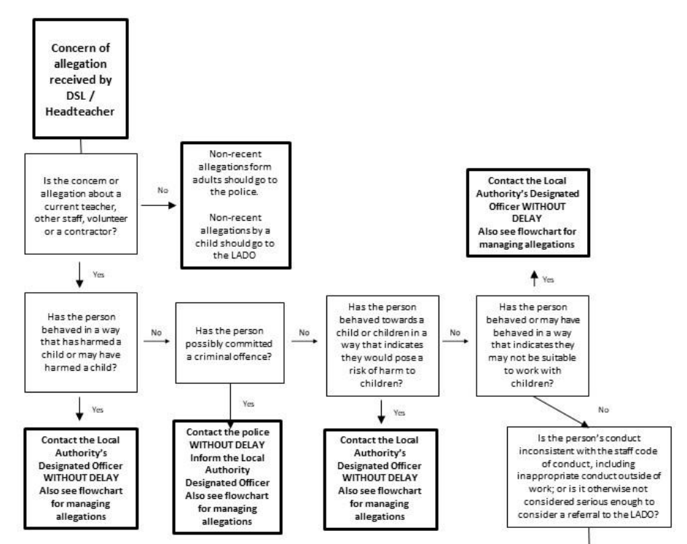
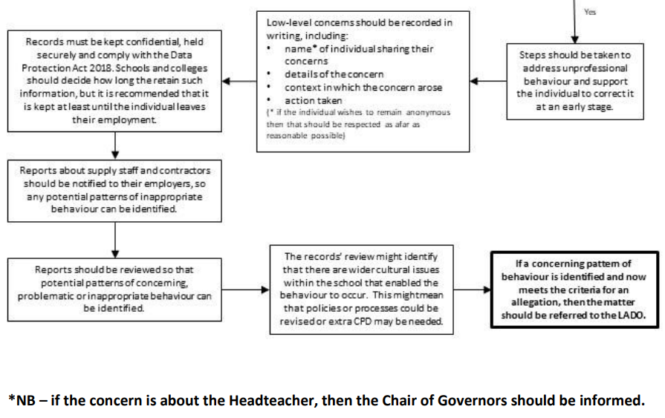
8: Low Level Concerns Reporting Form – Basnett Street Nursery School & The Chatterbox Club
